Department of Computer Science and Engineering (Data Science)
CSDS-A | Batch A2 (CSE - Data Science, Section A)
Attendance Magic: A Smart Geo-Fenced Attendance System with Live Challenge Verification
(Attendance Magic)
S.No. | Student name | Roll / hall ticket no.
1 | A.GREESHMA | 23K91A6706
2 | B.VINAY | 23K91A6740
3 | G.SRIRAM | 23K91A6757
4 | B.SAI KUMAR | 24K95A6704
Under the guidance of: [GUIDE NAME], [DESIGNATION]
BLOCK DIAGRAMS
This document collects every design diagram of Attendance Magic. Each diagram was drawn from the real code, database models and routes and is followed by a paragraph that explains it. The diagrams were generated by scripts/make_diagrams.py with matplotlib.
Table 1: Diagrams in this document
No. | Diagram | Shows
1 | System architecture | Layers: browser, React web app, FastAPI back end, core services, local models, SQLite storage
2 | High-level workflow | Ten steps from session creation to Excel export
3 | DFD level 0 | Context: Attendance Magic, the faculty member and the student
4 | DFD level 1 | Eight processes and four data stores
5 | DFD level 2 | Expansion of the face-verification process
6 | Use-case diagram | Actors and their use cases
7 | Sequence diagram | A student check-in from sign-in to the attendance record
8 | ER diagram | Five database tables
9 | UML class diagram | Persistent entities, services and result classes
10 | Algorithm flowchart | Control flow of the check-in pipeline

1 System Architecture
The architecture has four layers. Users work in a browser: the faculty member on a laptop and the student on a phone. The original Streamlit interface (port 8501) is kept and uses the same core services. The React front end (port 5102) provides twelve routes, the camera and location capture (getUserMedia or file upload, and the Geolocation API), the Leaflet map and the Recharts charts; its data layer sends the device identifier in the X-Device-Id header and the JWT as a bearer token. The Vite development server forwards /api to the back end, so phones need only one address.
The FastAPI back end (port 8102) is deliberately thin: its 27 endpoints translate HTTP to calls into the core/ package and keep the per-student check-in wizard state on the server. core/ holds all rules: authentication, device fingerprint, geo-fence, liveness, face matching, eligibility and the pipeline, and Excel export. Storage is a local SQLite database with five tables, and the two pre-trained models, MediaPipe Face Mesh and InsightFace buffalo_l, run on the CPU in the same process.
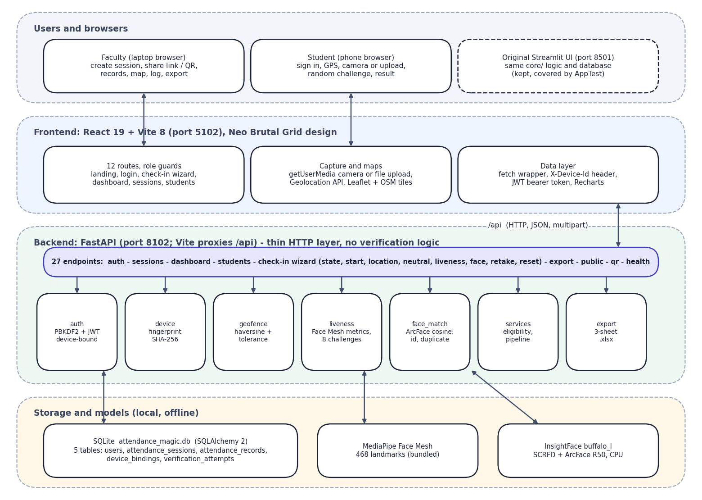
Fig. 1: System architecture of Attendance Magic

2 High-Level Workflow
The workflow has ten steps. The faculty member creates a session (1) and shares its link and QR code (2). The student opens the link and signs in (3); the server checks eligibility (4) and the geo-fence (5), issues a random live challenge (6) and verifies the face (7). A successful check-in writes the attendance record (8); the faculty member monitors records, map, log and analytics (9) and exports to Excel (10).
A failed stage stops the check-in with a plain reason and the attempt is logged. Three failed liveness tries lock the wizard until the student starts over.
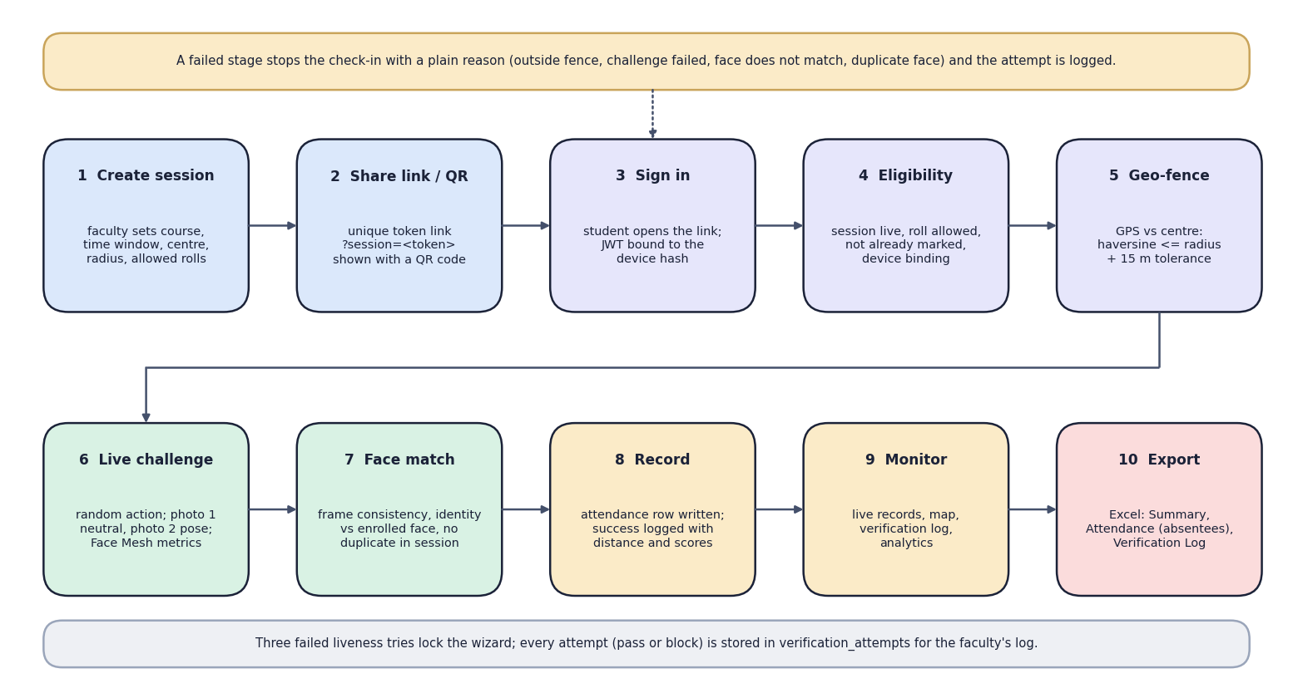
Fig. 2: High-level workflow from session creation to export

3 Data-Flow Diagram: Level 0
The context diagram shows Attendance Magic as one process with two external entities. The faculty member sends session details, roll patterns and commands (close, reset devices) and receives the session link and QR code, records, map, log and the Excel export. The student sends credentials, a GPS fix and two photos and receives the result of each step, with reasons, scores and the attendance confirmation.
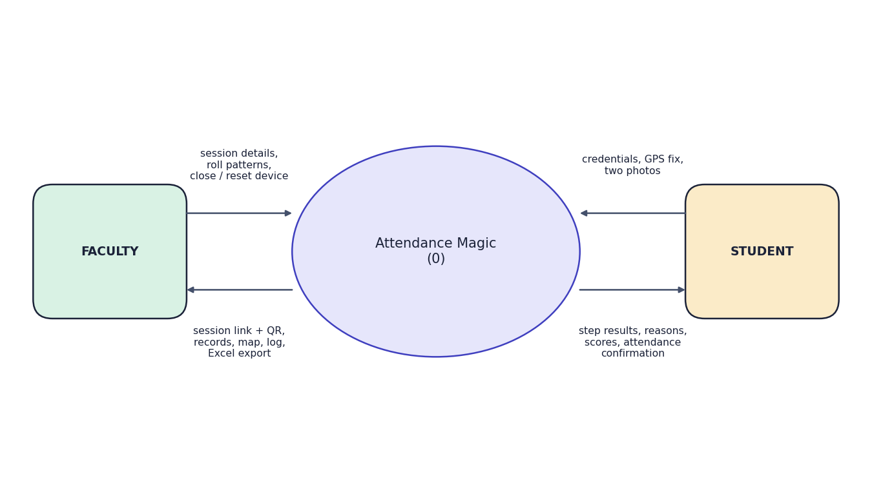
Fig. 3: Data-flow diagram, level 0 (context diagram)

4 Data-Flow Diagram: Level 1
Level 1 opens the system into eight processes and four data stores. Process 1 authenticates users against D1 (users). Process 2 manages sessions in D2 (attendance_sessions). Processes 3 to 6 form the student's verification chain: eligibility (reads D1 device bindings and D2 sessions), location, liveness and face verification. Process 7 writes the attendance record to D3 (attendance_records). Process 8 produces records, map, analytics and the Excel export from D2 and D3. Processes 3 to 7 append a row to D4 (verification_attempts) at every stage, shown by the dotted lines.
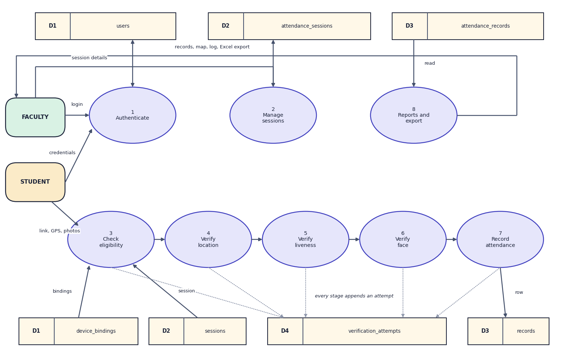
Fig. 4: Data-flow diagram, level 1

5 Data-Flow Diagram: Level 2
Level 2 opens the face-verification process into five steps. The two frames arriving from the liveness step are decoded and one face is detected in each (6.1). Frame consistency (6.2) requires the two photos to show the same person (cosine similarity at least 0.45). Identity (6.3) compares the first frame with the enrolled embedding in D1 (at least 0.40). The duplicate scan (6.4) compares it with every embedding already recorded in the session in D3 (maximum below 0.45). The decision (6.5) writes the reason and scores to D4 and either passes control to process 7 or returns the reason to the student.
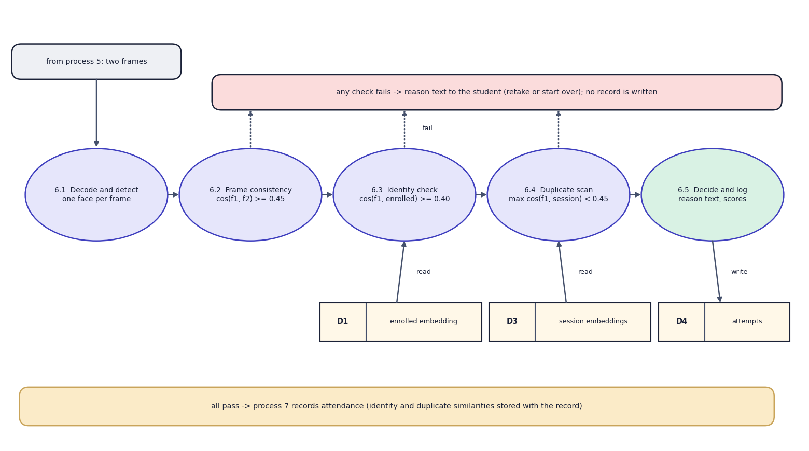
Fig. 5: Data-flow diagram, level 2: expansion of process 6 (verify face)

6 Use-Case Diagram
The faculty member can create a time-bound session, set the geo-fence and roll patterns, share the link and QR code, view records, map, log and analytics, export to Excel, close a session or reset devices, and enrol a student's reference face. The student can register with a reference face, sign in with a device-bound token, pass the eligibility check, verify location, complete the random live challenge, pass face verification and view the result. Every student step is logged in verification_attempts.
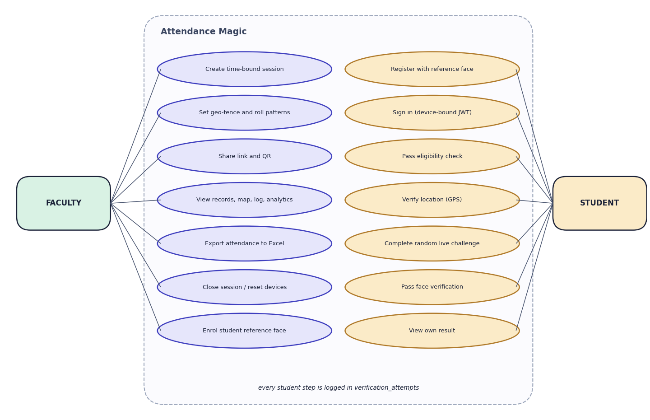
Fig. 6: Use-case diagram

7 Sequence Diagram
The sequence follows the main flow. The student opens the session link and signs in; the React app posts the credentials with the device identifier to /api/auth/login, and core.services.authenticate verifies the PBKDF2 hash and issues a JWT carrying the device hash. POST /start runs check_eligibility (reading the session, the existing record and the device bindings and binding the device on first use). POST /location runs check_geofence. POST /liveness receives the two photos, runs Face Mesh on each and verify_challenge. POST /face embeds both photos, runs verify_faces against the enrolled and the session embeddings, re-checks eligibility and inserts the record and the success attempt. The result returns to the student as the 'Marked. Present.' screen.
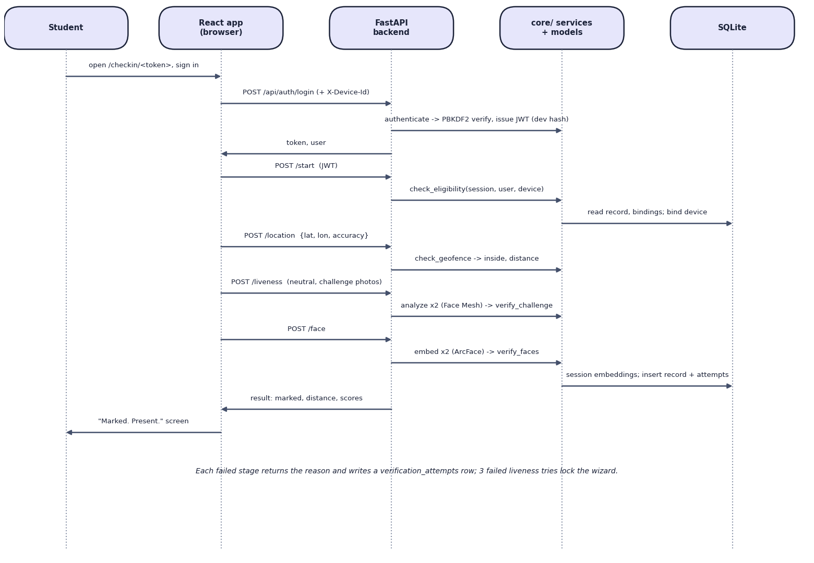
Fig. 7: Sequence diagram of a student check-in

8 Entity-Relationship Diagram
The database has five tables. users holds faculty and students (the student's reference embedding is a 512-float binary column). attendance_sessions belongs to a faculty user through faculty_id and holds the window, the geo-fence and the allowed roll patterns. attendance_records links a session and a student and stores the evidence of the check-in (distance, accuracy, challenge, liveness score, identity and duplicate similarities, device hash and the face embedding); a unique constraint on (session_id, student_id) makes a second record impossible. device_bindings stores the devices a student has used, unique per user and device. verification_attempts is the audit log, one row per stage attempt.

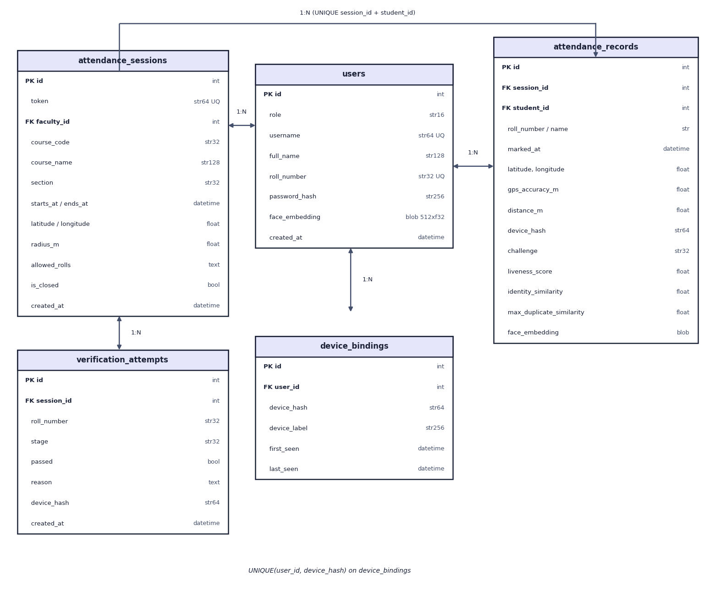
Fig. 8: Entity-relationship diagram of the Attendance Magic database (5 tables)

9 UML Class Diagram
The upper part of the class diagram shows the five persistent entities and their associations; AttendanceSession has the derived methods status (upcoming, live, expired or closed) and is_open. The lower part shows the modules of core/ and the plain result classes they return: MatchResult from face matching, FaceMetrics and LivenessResult from liveness, GeoResult from the geo-fence and Eligibility and PipelineResult from the services. Each decision returns a result object with a boolean outcome and a human-readable reason, which is what the API passes to the screen and writes to the log.

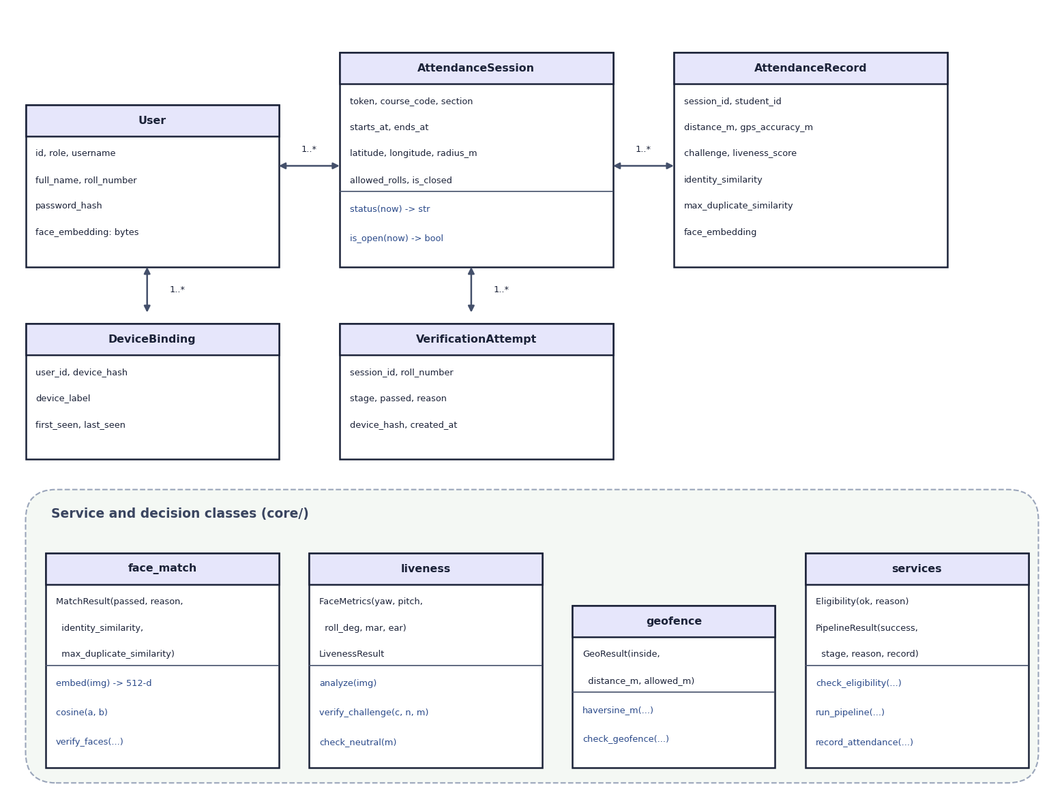
Fig. 9: UML class diagram: persistent entities and decision classes

10 Flowchart of the Core Algorithm
The flowchart is the control flow of run_pipeline and of the equivalent API wizard. After sign-in, eligibility is checked; then the geo-fence (accuracy at most 150 m and distance at most radius plus 15 m); then the liveness challenge on two photos (retry up to three times, with a new random challenge each time); then the embeddings of both photos; then frame consistency and identity; then the duplicate scan. Any 'no' leads to a block with a stored reason; only a full 'yes' chain records attendance.
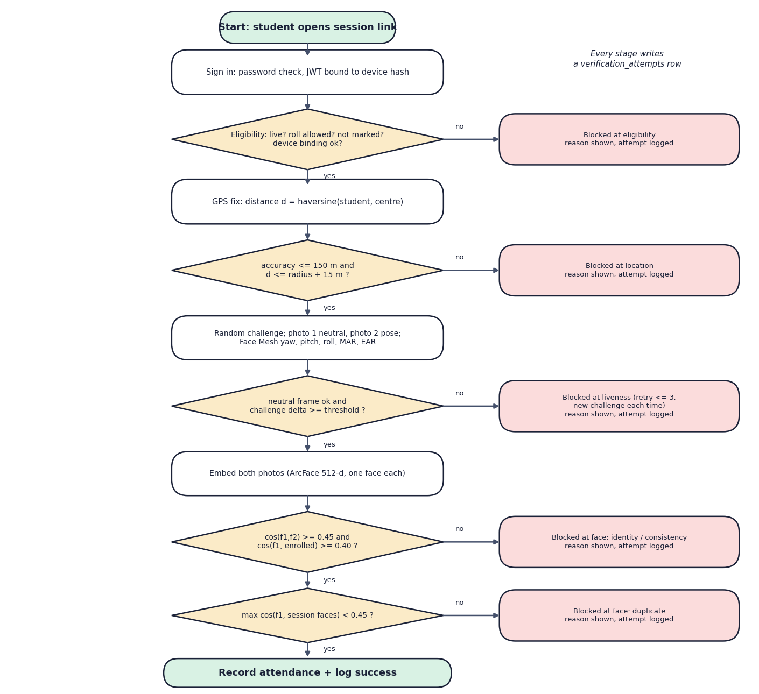
Fig. 10: Flowchart of the core check-in algorithm

